
Gatton College of Business and Economics

PROPOSAL FOR AN UNDERGRADUATE DOING BUSINESS IN AMERICA

SUMMER PROGRAM

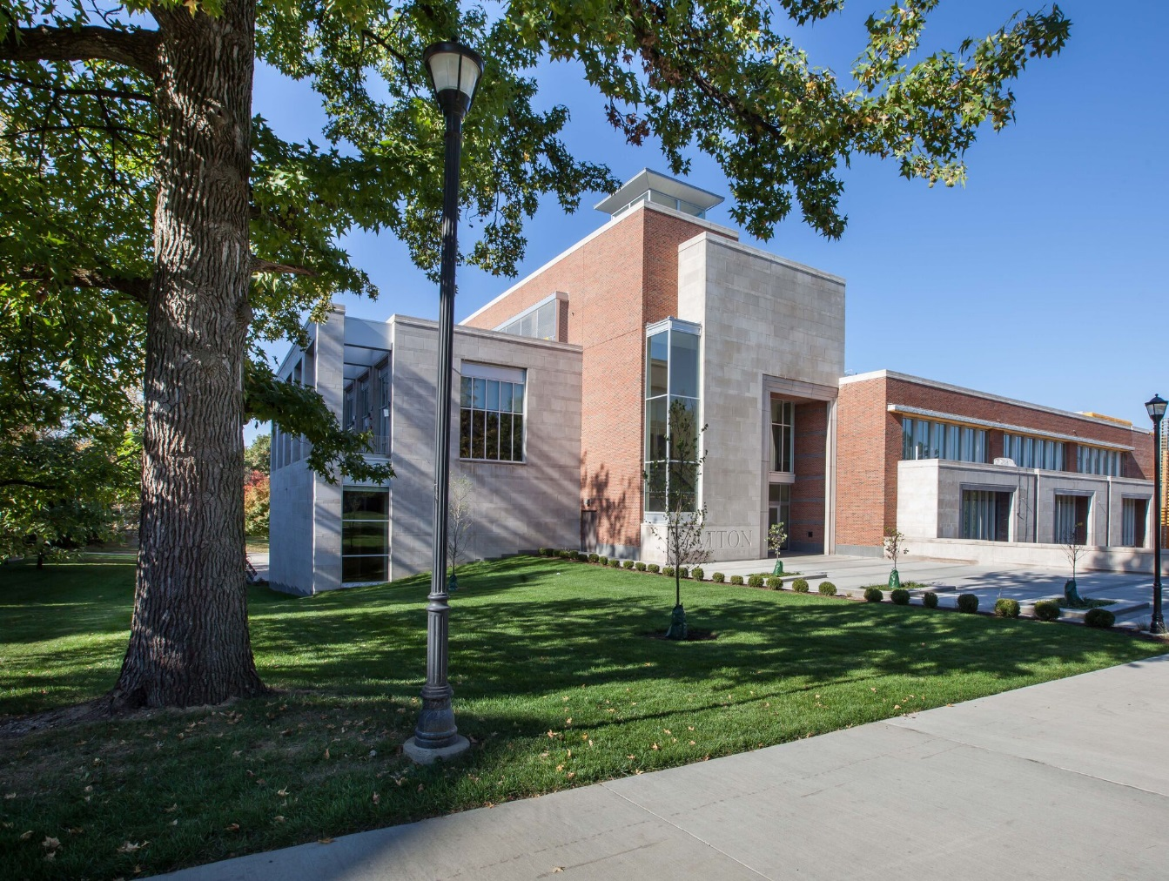

OBJECTIVE:

We propose to deliver a two-week program from July 16 to July 27, 2018 for undergraduates and accompanying faculty members from any major in business from universities in the Peoples Republic of China. The program will introduce students to American business practices and environment, as well as provide a cultural experience in the Midwestern United States.

POTENTIAL DATES AND LOCATION:

The series will be held in the new wing of the Gatton College of Business and Economics on the University of Kentucky campus in Lexington, Kentucky. Lexington is situated in the heart of the Bluegrass Region of Kentucky which is known for beautiful horse farms and friendly people.

PARTICIPANTS WILL LEARN:

Participants will be able to describe and discuss how Americans approach business and business culture.

FORMAT:

The proposed program, outlined in Appendix A, consists of a combination of faculty-led workshops, experiential exercises, site visits to businesses which will include manufacturing facilities, the service sector, and new ventures (via chartered bus motor coach), and cultural events. Approximately half of the time will be spent in the classroom and the other half will be site and cultural visits.
All sessions and most site visits will be translated into Mandarin. (A few of tours may be difficult to translate because of physical conditions.)
Below is a sample list of workshops, site and cultural visits.

Workshops:

When the participants leave they will have had workshops on the following:
- American culture and business
- The U.S. regulatory environment for business
- The American legal system
- American financial institutions
- Entrepreneurship and venture capital
- The American consumer
- Teamwork, American style
- Social issues and business (e.g., social entrepreneurship, environmental)
- American strategic decision-making
Several of these workshops will be supplemented by interactive experiences. Students will get to use modern financial software in our modern financial learning lab, explore team building, and simulate entrepreneurial activity in our New Venture Studio.

Potential site visits:
  - Toyota Motor Manufacturing (TMMK), headquartered in nearby Georgetown, KY, is a world-class lean manufacturer and the production facility for Lexus vehicles.
  - Alltech, based in nearby Nicholasville, KY, is a leader in the agricultural science space with operations in animal feed, meat, brewing, and distilling.
  - Valvoline, headquartered in Lexington, is a leading worldwide producer and distributor of premium branded automotive, commercial and industrial lubricants, and automotive chemicals.

Potential cultural visits:

  - Lexington Legends Baseball game
  - Old Friends Equine
  - Natural Bridge State Resort Park - great hiking and natural beauty
  - Muhammad Ali Center in Louisville – celebrating the legacy of a man who set an example of constructive international dialogue
  - Picnic at local home or park

HEALTH INSURANCE:

Participants will be required to provide travel health insurance for the participants while they are traveling in the U.S.

PROPOSED PROGRAM COST:

$3,750 per participant for instruction:

  - Opening ceremony
  - All classroom instruction from professors
  - All course materials
  - Lectures in Mandarin or language translation
  - Residence hall lodging in UK’s modern dormitories (rate quoted for two people sharing a room)
  - All ground transportation costs from arrival to departure
  - All field trips and site visits, including tickets to cultural activities
  - Graduation ceremony, and certificates of completion
  - No cost for faculty member attending the program (up to 1 faculty member per 15 students)

Please note: This quote does not include airfare.

CONTACT INFORMATION:

We thank you for allowing us the opportunity to work with you to develop a wonderful learning experience for your students and faculty. We look forward to speaking with you in greater depth about this visit. For more information, please contact:

Lorna Patches
Director
Don and Cathy Jacobs Executive Education Center
University of Kentucky
lornapatches@uky.edu

Appendix A: Tentative Schedule for Doing Business in America

 |  | Sunday | Monday | Tuesday | Wednesday | Thursday | Friday | Saturday
Week 1 | 8:00 - 9:00
Week 1 | 9:00 - 10:00 |  | Workshop: American Culture & Business | Workshop: The U.S. Regulatory Environment for Business | Visit Yum Brands, Louisville | Workshop: American Financial Institutions | Workshop: Entrepreneurship and Venture Capital
Week 1 | 10:00 - 11:00 |  |  |  |  |  |  | Outlet Shopping
Week 1 | 11:00 - 12:00 | UK Tour
Week 1 | 12:00 - 13:00 | Opening Ceremony | Lunch | Lunch | Lunch | Lunch | Lunch | Outlet Shopping
Week 1 | 13:00 - 14:00 |  | Visit World Trade Center | Workshop: The American Legal System | Visit the Muhammad Ali Center | Gatton Financial Lab | Entrepreneurship – New Venture Studio | Outlet Shopping
Week 1 | 14:00 - 15:00
Week 1 | 15:00 - 16:00
Week 1 | 16:00 - 17:00 | Free Evening | Free Evening | Movie Night |  | Lexington Legends Baseball Game | Free Evening | Outlet Shopping
Week 1 | 17:00 - 18:00 | Free Evening | Free Evening | Movie Night |  | Lexington Legends Baseball Game | Free Evening | Outlet Shopping
Week 1 | 18:00 - 19:00 | Free Evening | Free Evening | Movie Night | Free Evening | Lexington Legends Baseball Game | Free Evening | Farm Dinner Party at Muir Hill
Week 1 | 19:00 - 20:00 | Free Evening | Free Evening | Movie Night |  | Lexington Legends Baseball Game | Free Evening | Farm Dinner Party at Muir Hill
Week 1 | 20:00 - 22:00 | Free Evening | Free Evening | Movie Night |  | Lexington Legends Baseball Game | Free Evening | Farm Dinner Party at Muir Hill

 |  | Sunday | Monday | Tuesday | Wednesday | Thursday | Friday
Week 2 | 8:00 - 9:00 |  |  |  |  |  | Depart
Week 2 | 9:00 - 10:00 | Natural Bridge Resort Park | Workshop: The American Consumer | Workshop: Teamwork, American Style | Social Issues and Business | American Strategic Decision-Making | Depart
Week 2 | 10:00 - 11:00
Week 2 | 11:00 - 12:00
Week 2 | 12:00 - 13:00 | Natural Bridge Resort Park | Lunch | Lunch | Lunch | Closing Lunch
Week 2 | 13:00 - 14:00 | Natural Bridge Resort Park | Tour UK Behavioral Research Lab | Toyota | Lexmark Tour | Packing and Dinner on Own
Week 2 | 14:00 - 15:00 | Natural Bridge Resort Park | Guest Speaker | Toyota | Lexmark Tour | Packing and Dinner on Own
Week 2 | 15:00 - 16:00
Week 2 | 16:00 - 17:00 | Free Evening | Movie Night | Old Friends Equine | Free Evening | Packing and Dinner on Own
Week 2 | 17:00 - 18:00
Week 2 | 18:00 - 19:00 | Free Evening | Movie Night | Free Evening | Free Evening | Packing and Dinner on Own
Week 2 | 19:00 - 20:00 | Free Evening | Movie Night |  | Free Evening | Packing and Dinner on Own
Week 2 | 20:00 - 22:00 | Free Evening | Movie Night |  | Free Evening

